BASIC PROGRAMMING
CHAPTER 1 - INDIVIDUAL PRACTICAL ASSIGNMENT
STUDENT REPORT TEMPLATE
Assignment 1.1: Profile of a Tax Consultant & Tax Services

Student Information
Student Name : Garini SahasraKirana
Student ID (NIM) : 4.41.25.9.06
Class / Semester :KA-2IUP
Study Program : Computerize accounting
Submission Date : 20-9-2-26

Course Lecturer
Ahmad Wafa Mansur, S.ST., M.IM.
Computerized Accounting Study Program
Department of Accounting, Politeknik Negeri Semarang

Report Instructions
Complete only the sections below using your own Assignment 1.1 work. Keep explanations concise, use readable evidence, and export the completed report to PDF.

1. Assignment Information
Assignment
Project Folder | week_1/tax_consultant_profile/
Main File | week_1/tax_consultant_profile/index.html
Repository Link | [Type here, if requested]

2. HTML Source Code
Paste the final HTML code from Assignment 1.1. Use consistent indentation. Additional pages may be used if required.
[Paste the final Assignment 1.1 HTML code here]
<!DOCTYPE html>
<html lang="en">
<head>
<meta charset="UTF-8">
<meta name="viewport" content="width=device-width, initial-scale=1.0">
<title>Document</title>
</head>
<body>
<header>
<h1>Stary Night Co</h1>
<h2>Statement of Financial Position</h2>
<h3>31 December 2025</h3>
</header>

<main>
<section>Statement of Financial Position</section>
<table>
<Caption> For december 2025 </Caption>
<thead>
<tr>
<th>Account</th>
<th>Amount (IDR) </th>
</tr>
</thead>
<tbody>
<tr>
<th colspan="2">Assets</th>
<tr>
<td>Cash</td>
<td>10.000.000</td>
</tr>
<tr>
<td>Account Receivable</td>
<td>5.000.000</td>
</tr>
<tr>
<td>Inventory</td>
<td>15.000.000</td>
</tr>
<tr>
<td>Office Equipment</td>
<td>20.000.000</td>
</tr>
<tr>
<td>Buildings</td>
<td>50.000.000</td>
</tr>
</tr>

<tr>
<tr>
<th colspan="2">Liabilities And Equity</th>
</tr>
<th colspan="2">Liabilities</th>
<tr>
<td>Accounts Payable</td>
<td>8.000.000</td>
</tr>
<tr>
<td>Salaries Payable</td>
<td>2.000.000</td>
</tr>
<tr>
<td>Bank Loans</td>
<td>40.000.000</td>
</tr>
</tr>

<tr>
<th colspan="2">Equity</th>
<tr>
<td>Share Capital</td>
<td>35. 0000.000</td>
</tr>
<tr>
<td>Retained Earnings</td>
<td>18.000.000</td>
</tr>
<tr>
<td>Owners Drawings</td>
<td>- 3.000.000</td>
</tr>

<tr>

<tr>
<th colspan="2">Total</th>
<tr>
<th>Total Assets</th>
<th>100.000.000</th>
</tr>
<tr>
<th>Total Liabilities And Equity</th>
<th>100.000.000</th>
</tr>
</tr>

</tbody>
</table>

<p> Adjusment </p>
<ol>
<li>Beginning equity balance: IDR 35.000.000</li>
<li>Capital contributions from investors: IDR 15.000.000</li>
<li>Net profit for the period: IDR 5.000.000</li>
<li>Dividend withdrawals/drawings: IDR 3.000.000</li>
<li>Ending equity balance: IDR 50.000.000</li>
</ol>
<footer>
<P>Name : Garini SahasraKirana.</P>
<p>Nim : 4.41.25.9.06</p>
</footer>
</main>

</body>
</html>

3. Browser Result
Insert one or two readable screenshots showing the completed page and its required elements.
[Insert screenshot here]
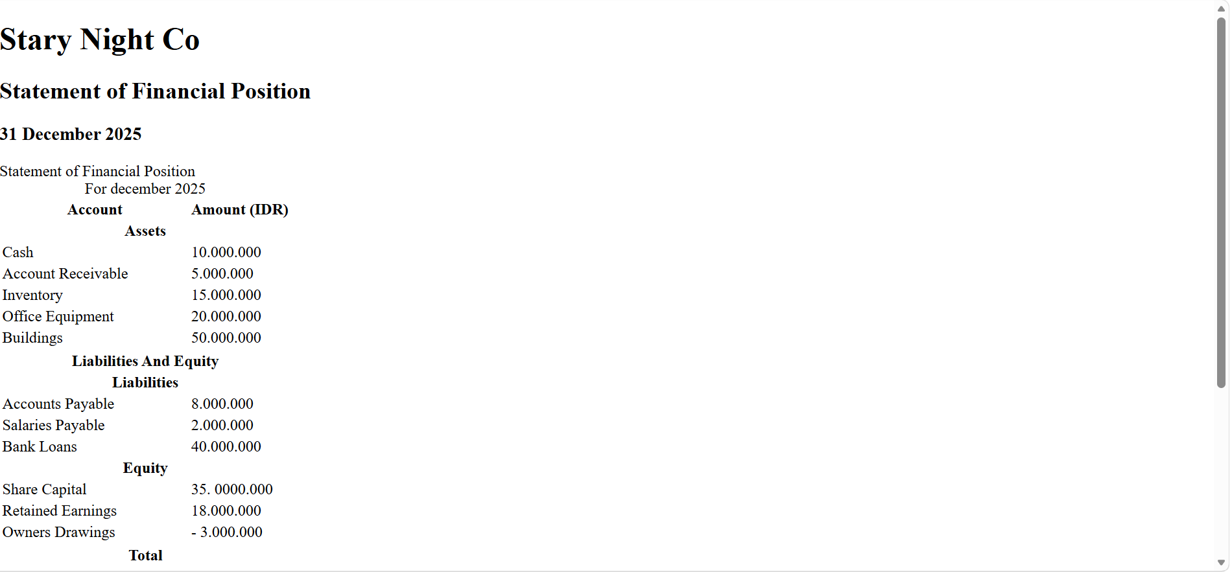
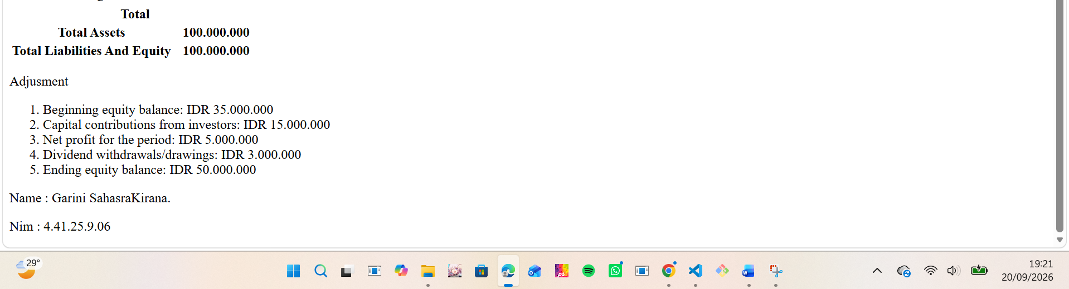

Caption: [Briefly describe what is shown]

3. Browser Result (continued)
[Insert screenshot here or write N/A]

Caption: [Briefly describe the tested links or elements]

4. Git Evidence
Insert one terminal screenshot showing the final Assignment 1.1 commit in git log.
Git Log Screenshot
[Insert terminal screenshot showing git log --oneline here]
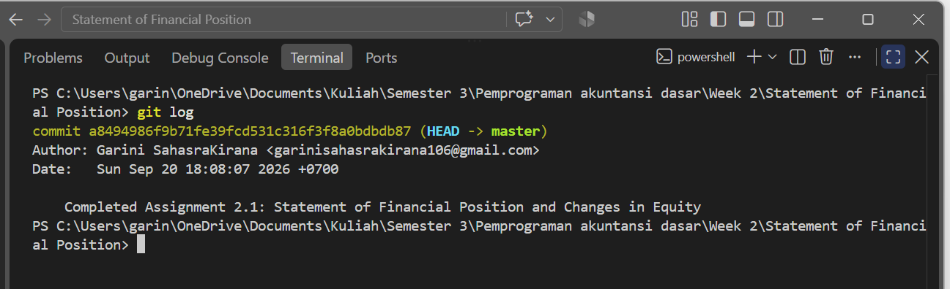

Commit hash: [Type here]
Commit message: Completed Assignment 1.1: Tax Consultant Profile and Services

5. Conclusion
Short Conclusion
HTML Report Completed: Successfully built the Statement of Financial Position web page, including financial tables, the Changes in Equity section using an ordered list (<ol>), and a footer containing your name and student ID.
Git Repository Initialized: Set up the Git repository in the main project folder (Pemrograman akuntansi dasar) using git init.
Changes Committed: Staged and committed all HTML files to the local Git repository with git add and git commit, which was verified through git log.

6. Final Checklist
☐ Student identity is complete.
☐ Final Assignment 1.1 HTML code is included.
☐ Browser screenshot(s) clearly show the completed page.
☐ The final Assignment 1.1 commit appears in the Git screenshot.
☐ The report has been checked and exported to PDF.
Student Name | Student Signature | Lecturer Signature
[Type here] | [Sign here] | [Sign here]

